**Assignment Number 5 –** CORRELATION ANALYSIS USING SPSS

Register Number: 1740256

**Date:** 08/01/2018

--------------------------------------------------------------------------------------------------------------------------------

1. **Aim** - To find the correlation between age & income in the data set bankloan.sav.

**Procedure** –

1. Choose any relevant file or enter the data manually.
2. Consider any 2 variables which can be correlated.
3. Choose correlate, go to analyse and then choose the bi-variate option.
4. Tick both Karl – Pearson’s and Spearman’s correlation coefficient.
5. Choose either 1- tailed or 2 – tailed level of significance.
6. Click ok.

**Calculations** –

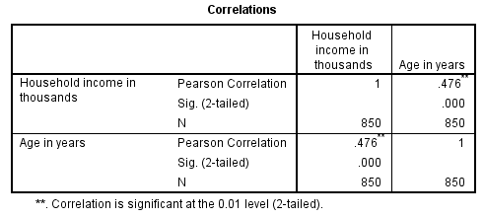

**Conclusion** –

We observe that Karl Pearson’s correlation between age & income is 0.475. Thus, there exists a low degree of positive correlation between age & household income.

------------------------------------------------------------------------------------------------------------------------------------

1. **Aim** - To obtain Spearman’s rank correlation coefficient for the given data set accidents.sav.

**Procedure** –

1. Choose any relevant file or enter the data manually.
2. Consider any 2 variables which can be correlated.
3. Choose correlate, go to analyse and then choose the bi-variate option.
4. Tick both Karl – Pearson’s and Spearman’s correlation coefficient.
5. Choose either 1- tailed or 2 – tailed level of significance.
6. Click ok.

**Calculations** –

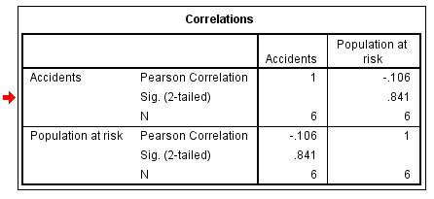

**Conclusion** –

We observe that Karl Pearson’s correlation between age & income is -0.106. Thus, there exists a low degree of negative correlation between Accidents & populations at risk.

------------------------------------------------------------------------------------------------------------------------------------

1. **Aim** - To obtain Spearman’s rank correlation coefficient for the data set employeedata.sav.

**Procedure** –

1. Choose any relevant file or enter the data manually.
2. Consider any 2 variables which can be correlated.
3. Choose correlate, go to analyse and then choose the bi-variate option.
4. Tick both Karl – Pearson’s and Spearman’s correlation coefficient.
5. Choose either 1- tailed or 2 – tailed level of significance.
6. Click ok.

**Calculations** –